IS-GLO-GD-031
Global Entity
Global Directory
Merial
DR Test Plan for
Oracle MSCA & Loftware Printers

Author: Letitia Sims
Creation Date: October 19, 2012
Last Updated: October 19, 2012
Version: 1.0

In the event of system failure, the following steps are to be followed until normally functioning systems are back online

Connect to Disaster Recovery Server
- Loftware Production Virtual Server – Replaced with Loftware DR Virtual Server:

Global Infrastructure will perform the following:
- Bring down am-usa38-loft01
- Place am-usa38-loft01 in a protected datastore
- Create a DR copy of am-usa38-loft01 which will be a mirror image of the actual am-usa38-loft01

- Connecting DR Loftware to DR BPTPRD:

- In order for labels to print from the DRP Oracle Instance, this instance will need to be connected to Loftware Connector Console
- You will need to connect to Loftware Connector Console with the DRP / BPTPRD TNS information below: Live BPTPRD and DRP tnsnames have been provided below as reference:

LIVE BPTPRD TNS names:
BPTPRD =
(DESCRIPTION=
(ADDRESS_LIST=
(ADDRESS=(PROTOCOL=tcp)(HOST=am-usa38-lin164-vip.merial.net)(PORT=1544))
)
(CONNECT_DATA=
(SERVICE_NAME=BPTPRD)
)

- DRP / BPTPRD TNS names:
BPTPRD=
(DESCRIPTION=
(ADDRESS_LIST=
(LOAD_BALANCE=YES)
(FAILOVER=YES)
(ADDRESS=(PROTOCOL=tcp)(HOST=am-usa39-lin214-vip.merial.net)(PORT=1544))
(ADDRESS=(PROTOCOL=tcp)(HOST=am-usa39-lin213-vip.merial.net)(PORT=1544))
)
(CONNECT_DATA=
(SERVICE_NAME=BPTPRD)
)
)

Note: Add the DRP tns names to your own computer’s tnsnames.ora file. Find this file at - C:\product\11.2.0\client_1\network\admin

These are for the old version of Oracle
C:\product\10.2.0\client_2\NETWORK\ADMIN and C Drive Backup\oracle\product\10.2.0\client_2\NETWORK\ADMIN and

How Live Production is currently connected to Loftware Connector Console:

- Go to internet explorer page
- Enter: http://am-usa38-loft01:8001/ConnectorConsole/initConnection.do
- Screen returns:
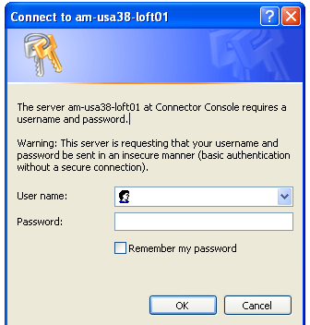
- User name: Loftware
- Password: console

- Screen returns:
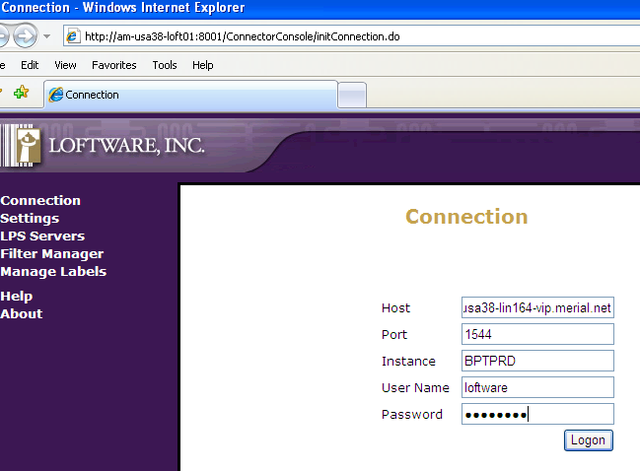

- Enter host information for Live BPTPRD: am-usa38-lin164-vip.merial.net
- Enter port information for Live BPTPRD: 1544
- Enter Instance: BPTPRD1
- Enter User Name: loftware
- Enter Password: loftware
- Click Logon

Screen Returns:
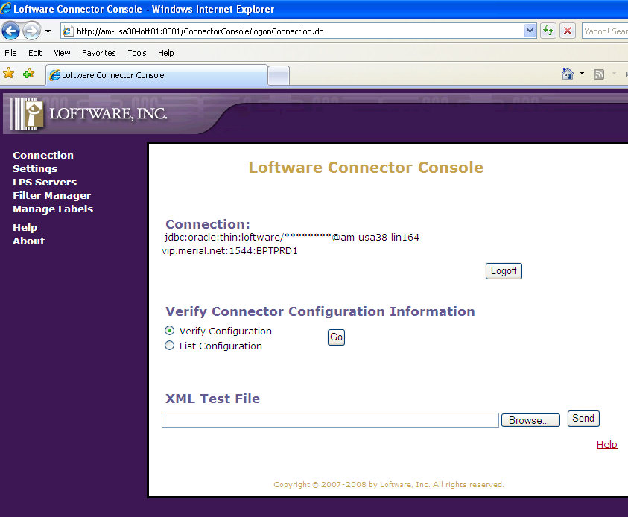

- Click Settings
- Screen Returns:

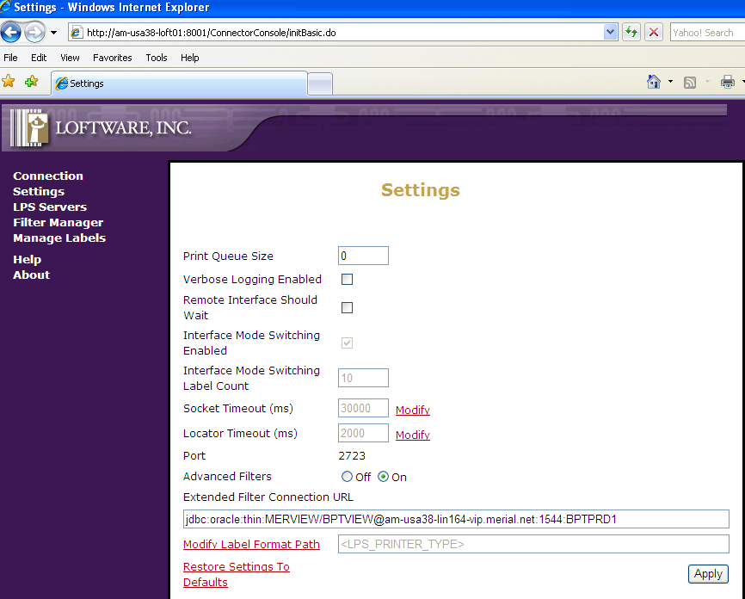

How to connect to the DR/BPTPRD instance to Loftware Connector Console:

- Go to internet explorer page
- Enter: http://am-usa38-loft01:8001/ConnectorConsole/initConnection.do
- Screen returns:
- User name: loftware
- Password: console
- Screen returns:
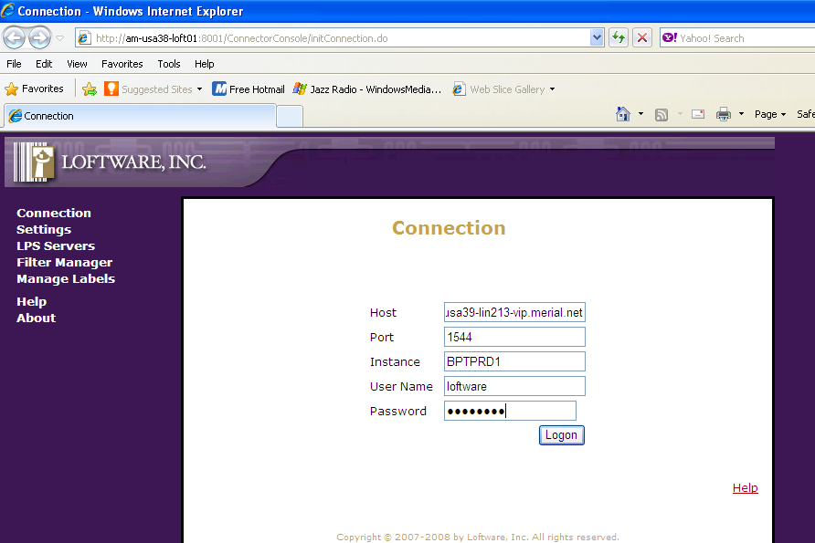

- Enter host information for DR / BPTPRD: am-usa39-lin213-vip.merial.net
- Enter port information for DR / BPTPRD: 1544
- Enter Instance: BPTPRD1
- Enter User Name: loftware
- Enter Password: loftware
- Click Logon

- Screen Returns:
Note: Connection: will show “…am-usa39-lin213-vip.merial.net:1544:BPTPRD1”

- Click Settings
- Screen Returns:

If the Advance Filters are set to “Off”, change the Advance Filters to “On”
- “Extended Filter Connection URL” will have the live BPTPRD URL listed. Enter the following URL for the “Extended Filter Connection URL”: jdbc:oracle:thin:MERVIEW/BPTVIEW@ am-usa39-lin213-vip.merial.net:1544:BPTPRD1
- Click “Apply”
- “Settings Updated” will return at the top

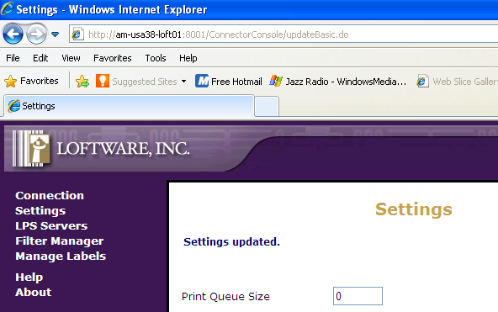

- Go to Loftware Print Server on AM-USA38-LOFT01 and bounce the Loftware Print Server
- Request Oracle DBA team to bounce MWA Services for US on server am-usa38-lin165.merial.net:10869 (unless otherwise instructed from the French team to include a bounce for their server as well - am-usa38-lin166.merial.net:10869

IMPORTANT NOTE: After testing is done in DR instance, go back and connect to the live production instance. This will ensure that connectivity to the live production instance is connected again and ready for business.

Bouncing Loftware Print Server

- Enter into the remote desktop connection:

- Enter server: am-usa38-loft01
- Click Connect
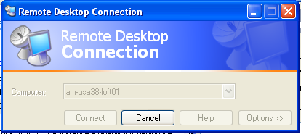

- Enter the following information:
User name: svc_loft_nam
Password: merial0815
Log on to: (choose) NAM

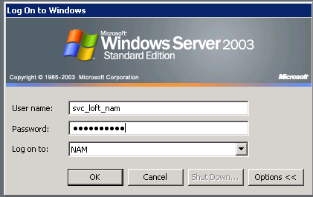

- Press OK
- To remote connection Start menu → Programs → Administrative Tools → Services

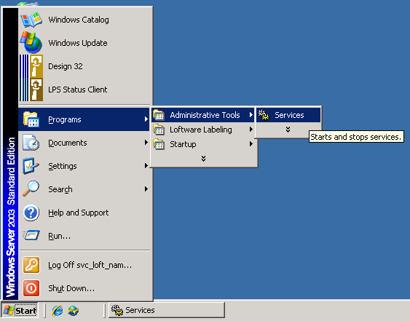

- Scroll down to Loftware Print Server and click

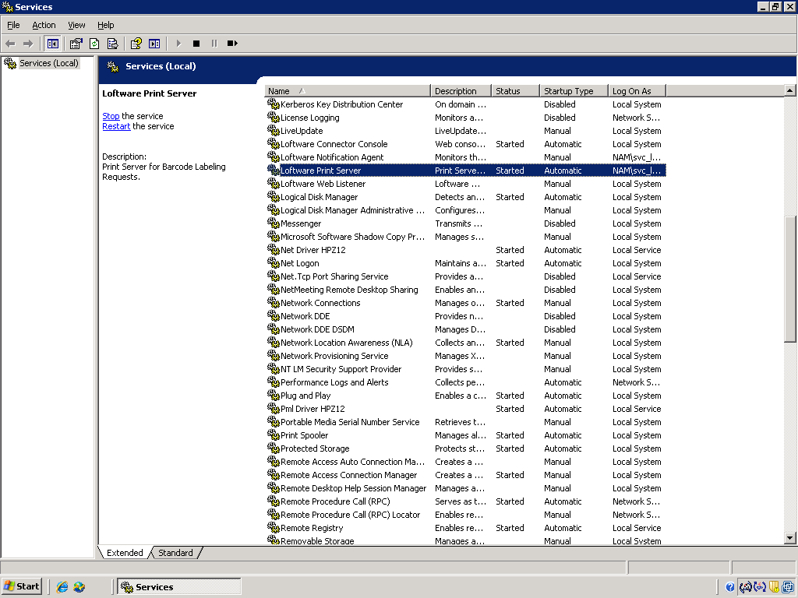

- Stop and Restart options will appear in the top left corner
- Click Stop the service

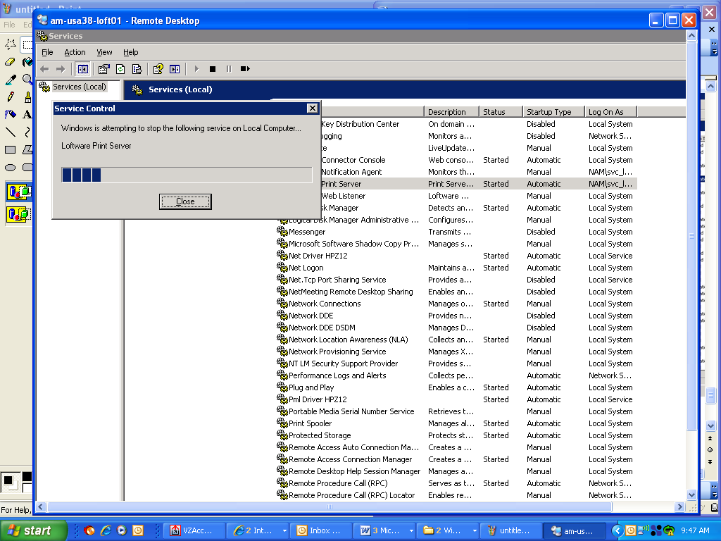

- Start Server again by pressing Start the service

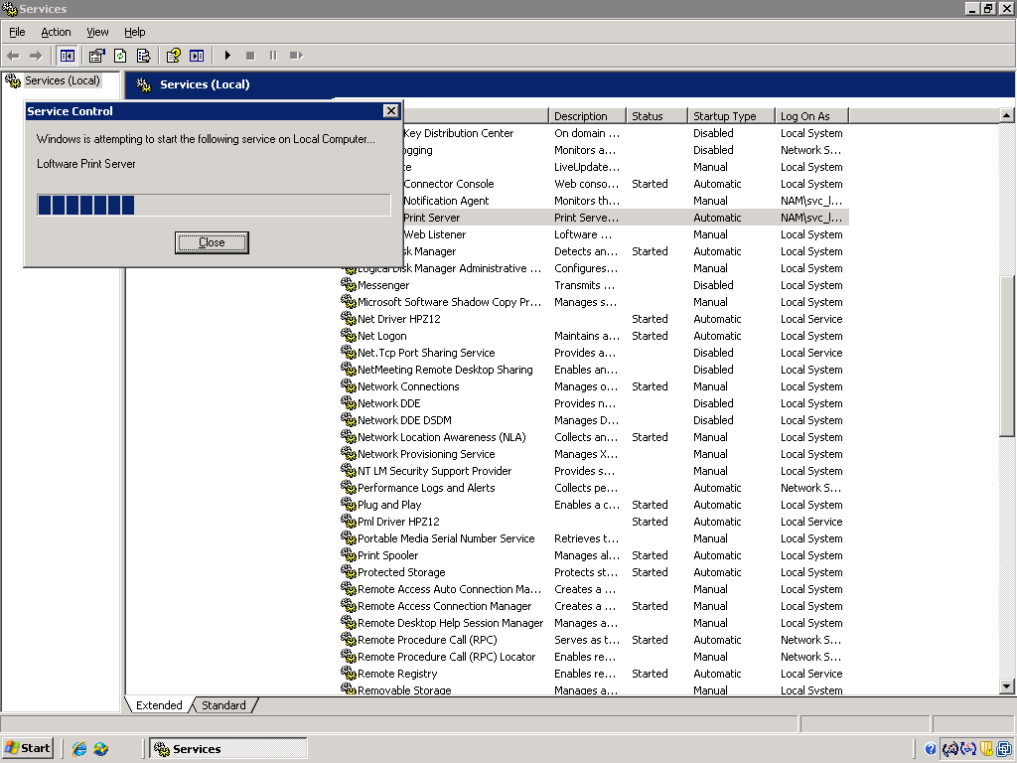

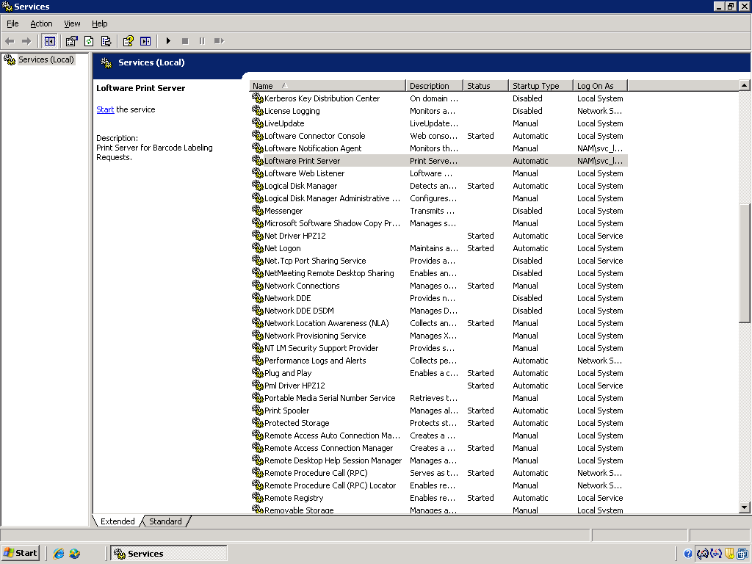

- Proceed with the remaining steps in the DR test script

